规格SPECIFICATION: Ø89平弧形 4Ω 15-30WROHS

样品编号SAMPLE NO: G89-R2004Y-01A

日期 DATE: 2023.10.25

|  |  |  |  |  |  |  |  |  |
| --- | --- | --- | --- | --- | --- | --- | --- | --- |
| 本厂型号  OUR PART NO | | G89-R2004Y-01A | | | 日 期  DATE | | 2023.10.25 | |
| 口径SIZE | | Ø89 | | | 全 高  TOTAL HIGH | | 43.5 | |
| 编号 | 项 目 | | 规 格 | | 测 定 条 件 | | | |
| 1 | 音圈阻抗VOICE COIL IMP | | 4±15% OHM（DCR） | | at 1.0V 1KHZ AT DC.R 20℃(Model-152A) | | | |
| 2 | 最低共振周波数  RESONANT FREQ. FO | | 100± 20% Hz | | At 1.0VWITHOUT BAFFLE(Model:7117C) | | | |
| 3 | 出力音压OUTPUT S. P. L | | 90±3dB | | AT 0.8,1.0,1.2,1.5K Hz 0.1M/0.1W(sound check 7.0) | | | |
| 4 | 输入功率INPUT S. P.L | | 定格入力RATED POWER INPUT 15W | | 最大入力MAX. POWER INPUT 30 W | | | |
| 5 | 实效周波数地域  FREQ. RESPONSE | | F0- 15 KHz | | OUTPUT S. P . L- 10dB | | | |
| 6 | 失真率DISTORTION | | ≤ 7 % MAX | | At 0.1M/0.1W @INPUT 1000 Hz | | | |
| 7 | 异常音  BUZZES & RATTLES | | MUST BE NORMAL | | SIN WAVE7.745 V Frequency range： 70HZ-3.5KHz Sweep time：0.5 second | | | |
| 8 | 连续负荷LOAD TEST | | White　 noise for 48 hours　 @ 15W input power. | | | | | |
| 9 | 耐热试验HEAT TEST | | Temperature : 55℃; Duration : 24 hours; Duration of recovery : 2 hours at 25℃ (room temp.); | | | | | |
| 10 | 耐寒试验COLD TEST | | Temperature : -20℃; Duration : 24 hours Duration of recovery : 2 hours at 25℃ (room temp.) | | | | | |
| 11 | 耐湿试验  HUMIDITY TEST | | Temperature : 40℃ ; Relative Humidity : 90-95 ％ ;  Duration : 24 hours ; Duration of recovery : 2 hours at 25℃ (room temp.) | | | | | |
| 12 | 温度循环  CYCLE TEST | | Temperature(℃ ) : 25→ 60→ 60→ 25→ -25→ -25→ 25 Duration : each step for 1 hour, 5 cycles(30 hours) Duration of recovery : 2 hours at 25℃ (room temp.) | | | | | |
| 13 | 跌落试验Drop Test | | Height : 1m Direction : concrete surface in 3 direction each with 1 cycles. | | | | | |
| 14 | 重量WEIGHT | | /g±15% | | | | | |
| 15 | 磁铁MAGNET | | 主磁/材质 | Ø60*Ø32*12H Y30 | | 副磁/材质 | |  |
| 16 | 音圈规格V．C．SIZE | | ASVØ20.4mm | | | | | |
| 17 | 极性REMARK | | **With positive voltage applied to “+” terminal, the cone shall move away from pole piece.**当正电压接至“+”的端子板时，纸盆移离上板 | | | | | |

1，Frequency Response Curve

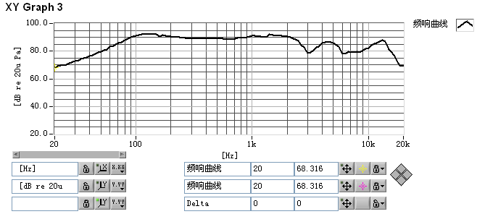

2， Impedance Characteristics Curve

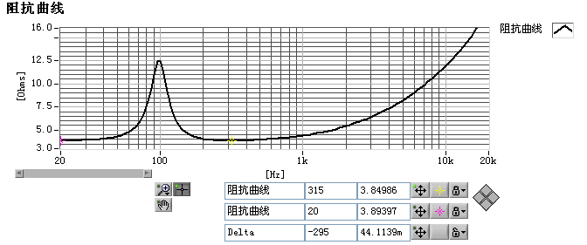

3，DISTORTION

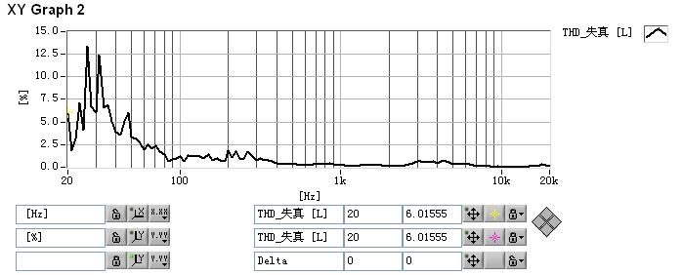

**4.** FREQUENCY MEASURING CIRCUIT

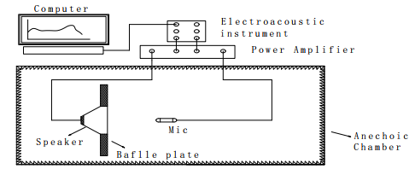

***5，***DIMENSIONS (Fig.4) 未注公差±0.5（MM）

